**RPS 205 Freshmen and Climate Change: “It’s real, we’re concerned, but we are optimistic”**

In a recent survey of 98 RPS205 Freshmen found that 88% are convinced that changing weather patterns are a serious issue. 72% are concerned or very concerned about the impact of climate change. The survey, conducted during the RPS205 Career Academy Expo, was sponsored and administered as a partnership between Sustain Rockford and Forest City Sustainability. This result aligns well with a 2021 Stanford study1 that found that “about three-quarters of young people felt that the ‘future is frightening’”. Interestingly, the Rockford study revealed that two-thirds of the students expressed optimism that global climate change will be managed in their lifetimes (hopeful or very hopeful).

[1https://globalhealth.stanford.edu/beyond-stanford/new-study-finds-high-levels-of-climate-anxiety-in-youth.html/](1%20https:/globalhealth.stanford.edu/beyond-stanford/new-study-finds-high-levels-of-climate-anxiety-in-youth.html/)

**About RPS205:** RPS205 is the Rockford Public Schools district in Rockford, Illinois. It is one of the largest school districts in the state. According to their web site2, RPS205 has 27,700 students, 41 schools, and 4071 employees. The school district was not responsible for the design or administration of this survey.

2<https://www.rps205.com/page/about-rps-205>

**About the Career Academy Expo:** The Expo provides Freshman students exposure to various careers in a safe and welcoming environment. It is designed to aid students in obtaining the most relevant high school experience given their career goals. Community experts are invited to participate as representatives of their fields and their organizations.

**About the Survey:** This survey was designed to explore student attitudes related to climate change, their level of concern, their hopefulness, and some sense of ability to make a difference. There are only 5 questions. It was administered on paper and by smart phone using a QR code. The survey and results are available on the Sustain Rockford website3. A detailed review of the results is included below. It is desired to repeat this survey annually to allow the detection and evaluation of trends.

3https://sustainrockford.org/

About **Sustain Rockford:** Sustain Rockford is a 501(c)(3) non-profit, grass-roots organization. Sustain Rockford’s main vision is to be a community organization that educates and advocates for practices and policies that protect our community’s land, air, and water to benefit all. We work to accomplish this by close collaboration with those citizens, organizations, businesses, and governmental bodies that have a heart for our community and its ongoing sustainability and resilience. Sustainability is not just about air, water, and clean energy. It is also about social equity, economic stability, equal opportunities, and health. We often talk about the triple bottom line – people, planet, and profit. True sustainability must include all three.

**About Forest City Sustainability:** Forest City Sustainability empowers small businesses in the Rockford region to implement their own sustainability initiatives with credibility and confidence. Forest City Sustainability designed and funded the survey. [www.forestcity.eco](http://www.forestcity.eco)

**Detailed Survey Analysis**

**The Respondents**

The respondents were attendees of the RPS205 Career Academy Expo. These are Freshmen from each of the Rockford High Schools. Those that approached the Sustain Rockford / Forest City Sustainability booth were asked to participate in the survey. All surveys were in English, limiting the accessibility to some of the newer members of the community.

**Question 1: Belief**

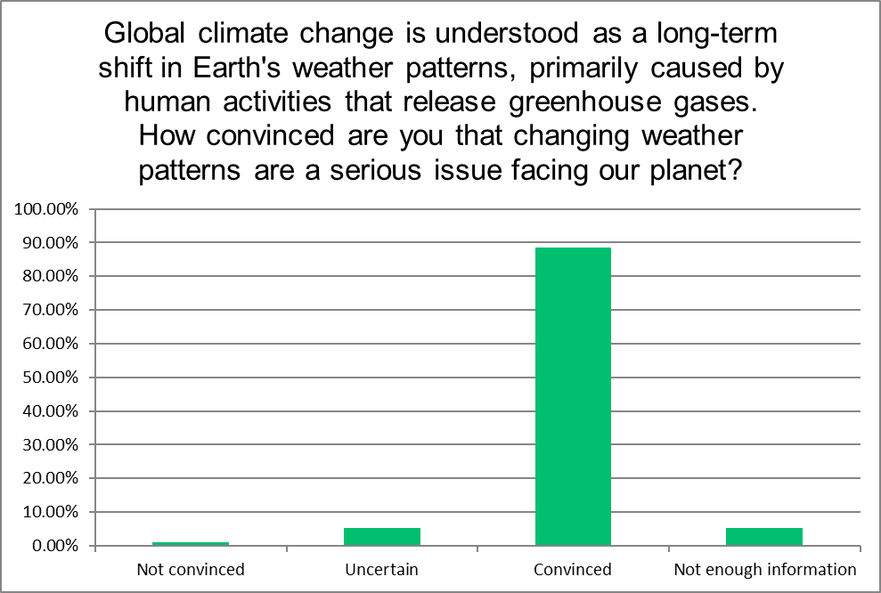

The result, that 88% of the respondents indicated they were “convinced”, suggests that Rockford teens believe that global climate change is real and it’s a serious issue. This level of support was not expected in the context of this election year, where the nation is evenly divided politically, and the two parties have lined up on opposite sides of climate policy.

**Question 2: Concern**

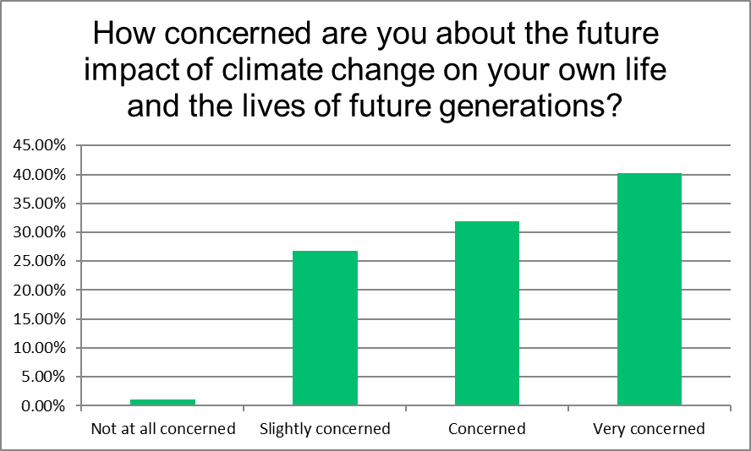

72% responded either “concerned” or “very concerned”. Of course, there isn’t a right or wrong answer to this question, and the specific point response isn’t perhaps as important as a trend over time. It is proposed that the level of “very concerned” will increase as the frequency and magnitude of severe weather events increase. In the context of exploring possible careers, the attentive student might realize that the word “impact” is without direction. Climate change will create new opportunities and create demand for career paths that have not yet been imagined.

**Question 3: Hopefulness**

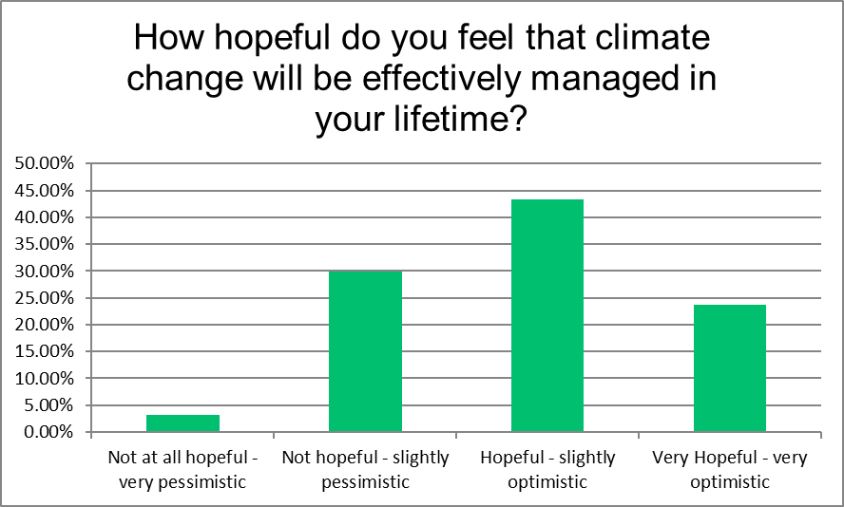

The results skew decidedly toward the optimistic. 76% expressed some level of optimism. Students can see evidence of action with wind turbines on the horizon, solar panels on rooftops and in fields, and electric vehicles on the roads. They probably don’t see the continued rate of increasing greenhouse gases in the atmosphere as seen on the monthly update to NOAA’s Keeling Curve4.

4https://gml.noaa.gov/ccgg/trends/

**Question 4: Purpose**

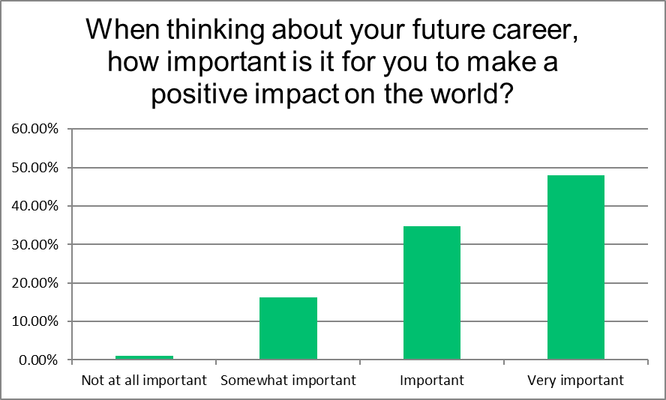

83% of the respondents indicated that it is important or very important to make a positive impact on the world. One possible takeaway is the businesses and organizations that hope to hire these students will have an advantage if they are seen as a force for good, if not specifically through the products and services they offer, then in how they operate, and the role they play in the community.

**Question 5: Agency**

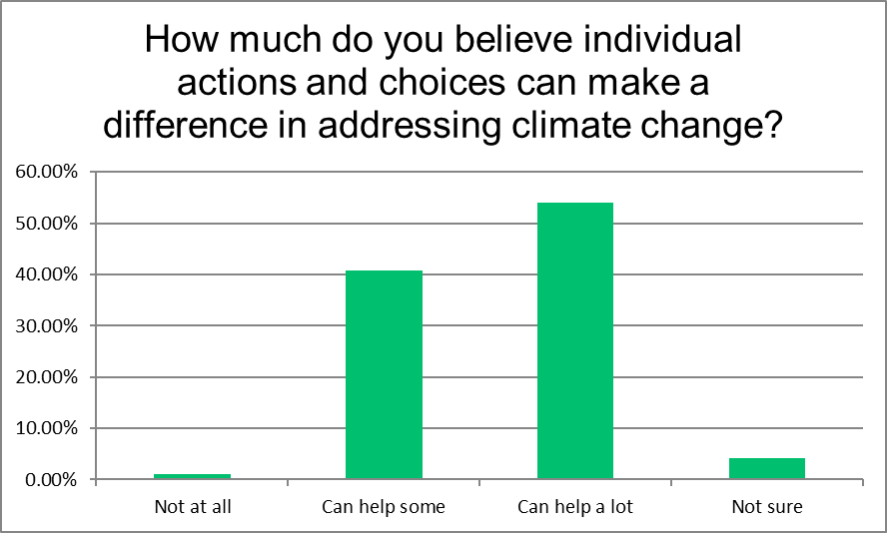

More than 50% of respondents indicated that individual action “can help a lot” and 95% indicate that individual action can at least have some contribution. This paints a compelling picture of this generation. They get that climate change is real, and it is causing them some concern. But they are optimistic that we will figure this out and that people taking individual action is seen as a valid approach. Unanswered is whether these freshmen think that it is their individual actions that can help or if it is the literal adults in the room that are so empowered.

For more information, contact:

Paul Schweitzer

Principal

Forest City Sustainability

Paul@ForestCity.eco

Brad Roos

President

Sustain Rockford

BradRoos@SustainRockford.org